Yukon Snow Survey Bulletin & Water Supply Forecast
March 1, 2024



THIS DOCUMENT WAS CREATED PROGRAMMATICALLY AND REQUIRES HUMAN REVIEW.
Specific things which MUST be modified include:
- The Figure Legend needs to be moved to the correct location. It belongs on the page before where it is automatically placed and should live beside the Figure A/B/C/D/E explanations.
- The notes below the table (at the very end) have several pseudo-headings which by default use Heading 3. These pseudo-headings must be modified to use heading tbl_notes instead of Heading 3 so that they do not show up as items in the navigation pane.
Some other items require checking and may need modification:
- Some paragraphs must manually be attached to their images, otherwise they may be on different pages. To do so, select the image and paragraph which belong together, then click the small ‘down-right’ arrow in the ‘paragraph’ section of the Home pane. This will open a menu where you can control paragraph settings. Select the ‘Line and Page Breaks’ tab and tick the boxes for ‘Keep with next’ and ‘Keep lines together’. This will ensure that the image and paragraph stay together on the same page.
- The paragraphs immediately after graphs C and D requires user modification, as these are not always the same and depend on interpretation.
- Carefully check each hydrograph and SWE graph for erroneous data. Depending on the source, modifications may be required either to the WRB data source (Aquarius) or requested to be made by the WSC. Once modification are made, the remote data must be synchronized to the local database using the AquaCache::synchronize_contiuous function.
- If precipitation data is missing, ensure that it has been brought in to the database manually (Mike Smith is the data source).
- If the CDDF plots have missing data points you’ll need to impute the missing data. Most often, a day is missing data because of a few hours of missing temperatures. The database automatically brings in hourly and daily mean temperature data as separate timeseries, so you can use the hourly data to impute the missing daily data. Use function AquaCache::imputeMissing to do this, starting with the hourly data; then, impute the daily data using the hourly data. Refer the function documentation for help.
REMEMBER TO DELETE THIS PAGE WHEN FINISHED.

Preface
The Department of Environment’s Water Resources Branch issues the Yukon Snow Survey Bulletin and Water Supply Forecast three times annually – early March, April and May. The bulletin provides a summary of winter meteorological and streamflow conditions for the Yukon, as well as current snow depth and snow water equivalent observations for 57 locations. This information is used to evaluate the potential for spring flooding caused by both breakup ice jams and large spring snowmelt (freshet) flows. It is important to note that other processes such as summer rain and glacier melt can significantly influence maximum annual water levels in specific Yukon basins.
Weather conditions for the Yukon are presented in two maps, one showing temperature anomalies (deviation from climate normals), and another showing precipitation anomalies. Territory-wide snowpack data are presented in a third map showing Snow Water Equivalent (SWE) as a percent of historical median for each station, as well as the basin-averaged estimated SWE for 11 watersheds (or river basins). Where available, complementary meteorological and hydrological data are presented for each basin through a series of plots, detailed below. Not all basins contain the instrumentation to support all five figure types.
- Figure A: Daily SWE data starting in September at one specific location in the watershed, showing an overview of winter snowpack evolution compared with historical data (period of record where available or historical point measurements).
- Figure B: Current, basin-averaged estimated SWE from snow survey data compared with historical data (period of record), serving as an indicator of potential runoff volumes in the spring (acknowledging that snow sublimation, evapotranspiration, rain and glacier melt also significantly affect runoff).
- Figure C: Monthly winter precipitation (rain and/or snow) compared with historical data (last 40 years), complementing the information presented in Figure B.
- Figure D: Cumulative degree-days of freezing (CDDF, sum of negative daily temperatures) compared with historical data (period of record), functioning as an indicator of winter coldness and overall river ice thickness; variables that influence river ice breakup scenarios in the spring.
- Figure E: Current, estimated daily discharge or measured water level compared with historical data (period of record), representing an overview of the watershed hydrological conditions. The flood level refers to the lowest elevation at which flood impacts are estimated to occur.
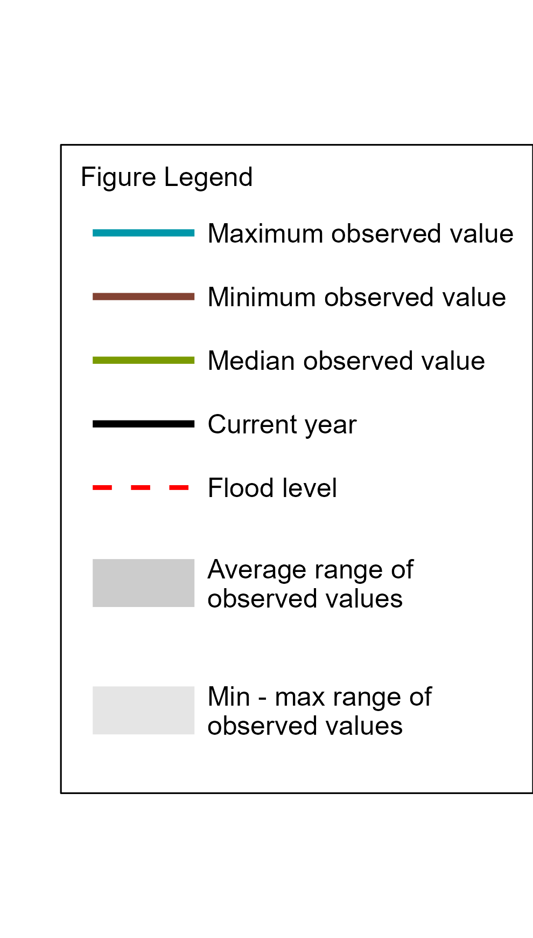
For information about the bulletin, snowpack conditions, or streamflow projections please contact waterlevels@yukon.ca
Water Resources Branch, Department of Environment
(867) 667-3171, toll free (in Yukon, NWT, Nunavut): 1-800-661-0408, ext. 3171
Fax: 867-667-3195 | Email: waterresources@yukon.ca
This bulletin as well as earlier editions are available online at:
Yukon.ca/snow-survey
ISSN 1705-883X
Reference to this report should be made in the following form:
Yukon Snow Survey Bulletin and Water Supply Forecast, March 1 2024
© March 2024
Water Resources Branch
Department of Environment
Government of Yukon
Box 2703, Whitehorse, Yukon Y1A 2C6

Acknowledgements
The Yukon Snow Survey Bulletin forms part of the Yukon Snow Survey Program administered by the Water Resources Branch, Department of Environment, Government of Yukon. The Water Resources Branch (WRB) strives for water stewardship in the Yukon and is committed to responsible and collaborative monitoring to inform the management and protection of waters.
We are grateful to monitor snow and water across the territories of all fourteen Yukon First Nations and to work in partnership with many First Nations in different aspects of our work. Though the findings expressed in this report are based primarily on field observations and relevant scientific data, we acknowledge the deep and longstanding connection to, and knowledge of, snow and water held by Yukon First Nations.
Gathering snow measurements and data from across our vast territory requires working together with several partners. We’d like to recognize the following agencies/individuals for their significant contributions to the snow survey bulletin:
- Data Collection Officer, Natural Resources Conservation Service, United States Department of Agriculture
- Meteorologist, Wildland Fire Management, Yukon Department of Community Services, Whitehorse
- Officer in Charge, Water Survey of Canada, Whitehorse
- Water Management Engineer, Yukon Energy Corporation
- Research Technologists, McMaster University
Agencies cooperating with the Yukon Ministry of Environment in the Snow Survey Program are:
- B.C. Ministry of Environment, Water Stewardship Division
- Parks Canada, Kluane National Park and Reserve
- Yukon Department of Highways and Public Works
- Yukon Department of Energy Mines and Resources, Compliance Monitoring and Inspections Branch
- Yukon Department of Environment, Client, Business and Technology Solutions
- Vuntut Gwitchin First Nation

Disclaimer and Limitation of Liability
The User understands and acknowledges that the use of the data is solely at their own risk. The User is solely responsible for confirming the accuracy, availability, suitability, reliability, usability, completeness or timeliness of the data.
The User accepts the data “as is” and acknowledges that the Government of Yukon makes no warranties or representations (express or implied) with respect to the accuracy, availability, suitability, reliability, usability, completeness or timeliness of the data, including, without limitation, implied warranties for merchantability, fitness for a particular purpose, and non-infringement.
In consideration of access to the data, the User also agrees that in no event will the Government of Yukon be liable (in tort or contract) or responsible whatsoever to the User or any other legal entity for the accuracy, availability, suitability, reliability, usability, completeness or timeliness of the data, including, without limitation, any loss of revenue or profit, or for direct, indirect, special, incidental, or consequential damages arising from or related to the data.

Yukon Territory Weather and Snowpack Conditions
October
November
December
January
February
March
April
Snowpack

Yukon Territory Flow Conditions and Outlook
Winter discharge (or baseflow) is estimated based on a combination of periodic winter measurements as well as historic data and regional trends. While most sites have had recent measurements it should be noted that discharge estimates are provisional at all stations.
Winter river discharge or lake water levels are presented at one or two important indicator sites within each basin. Winter discharge and water levels are affected by many factors including the previous year’s snowpack, annual rainfall, pre-existing groundwater conditions, freeze-up timing, and landscape changes. Increasing winter baseflow is an observed trend across the territory and is documented in the Yukon’s State of the Environment Report. The Yukon’s climate is predicted to trend wetter over time, but permafrost degradation may also be contributing to greater groundwater recharge, resulting in more winter baseflow.
[PLACEHOLDER FOR FLOW CONDITIONS INTERPRETATION]

Map 1. Temperature Anomalies
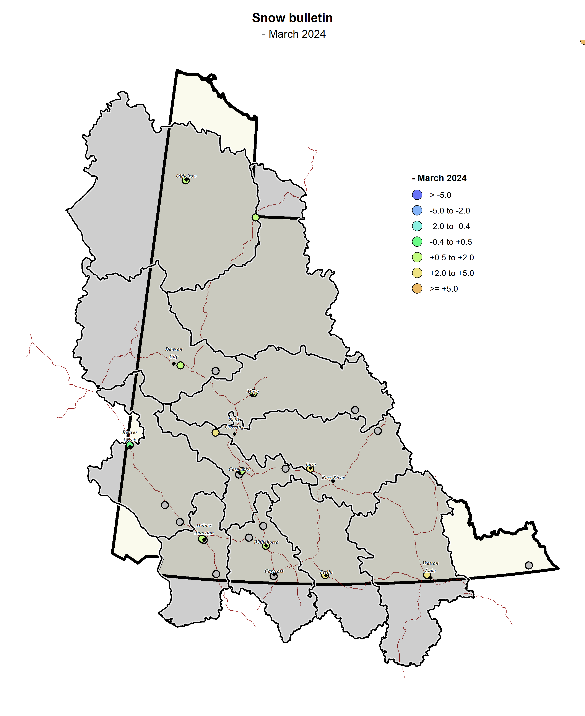 # Map 2. Precipitation
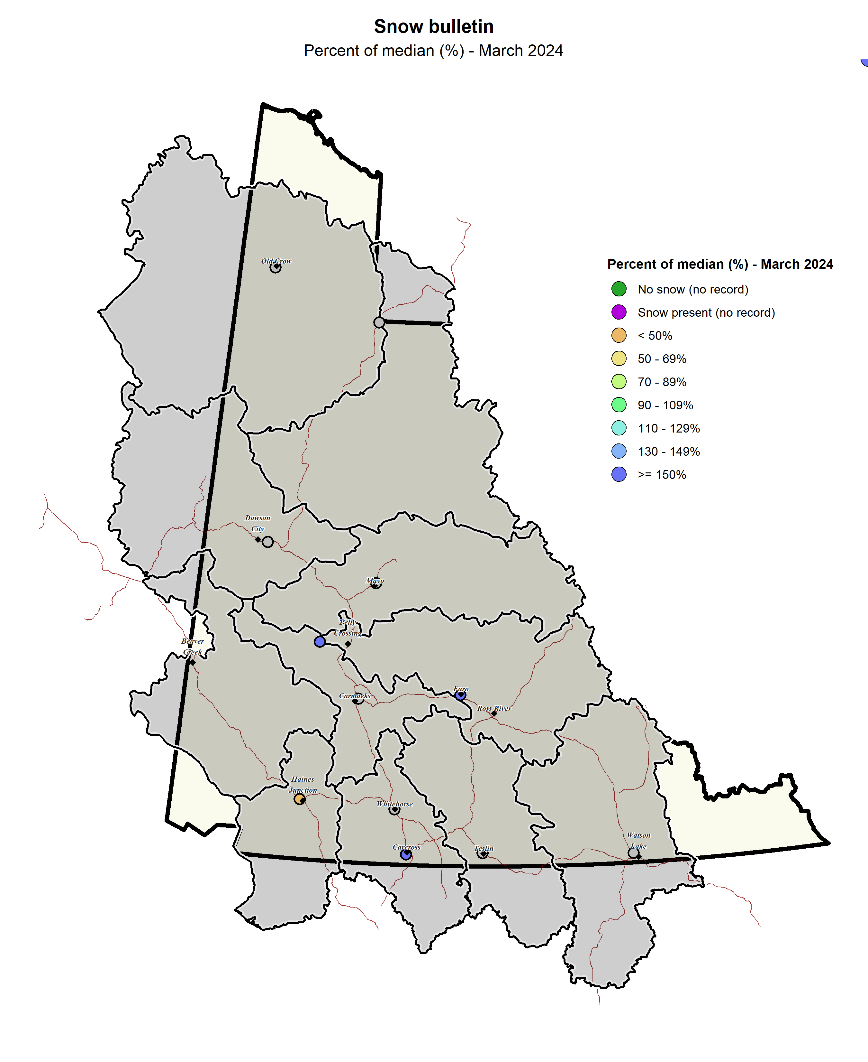

Map 3. Snow Water Equivalent
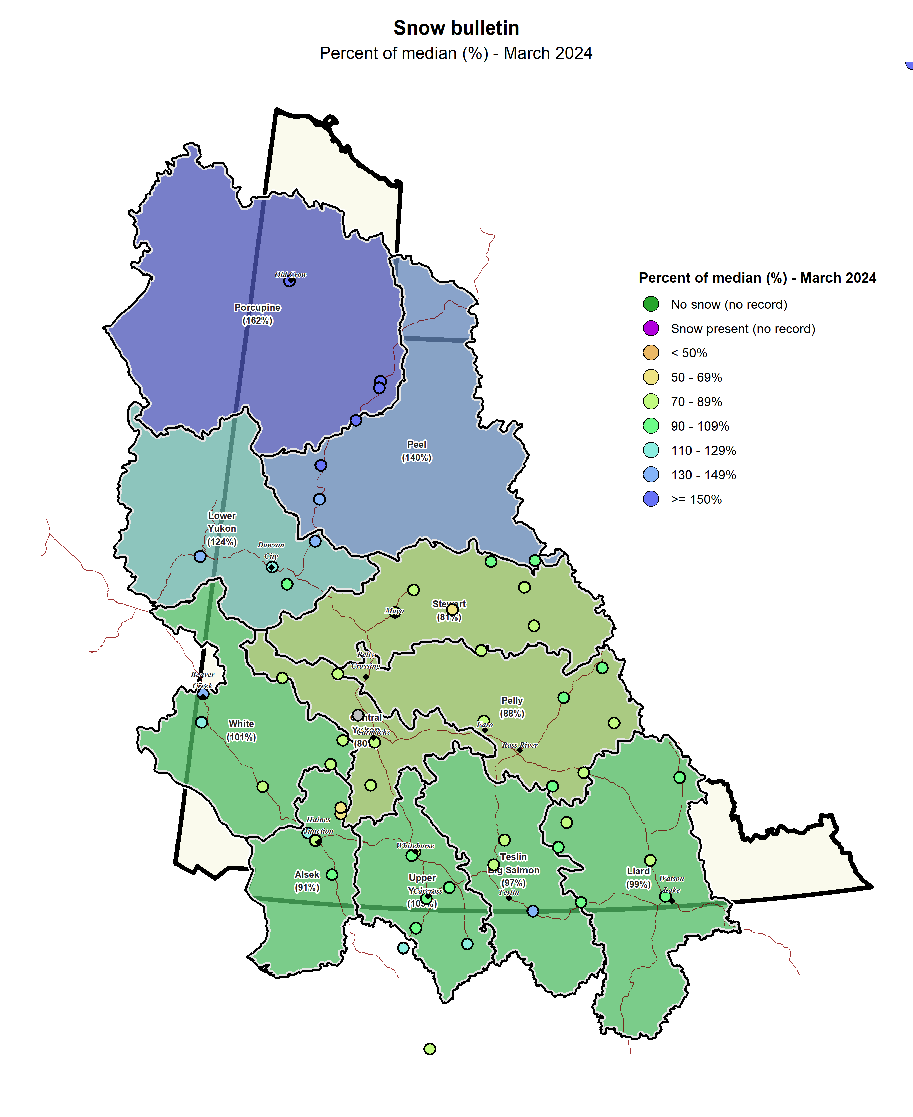

Upper Yukon River Basin (Southern Lakes/Whitehorse)
The Upper Yukon River Basin snowpack is close to average. At Tagish Meteorological Station, Snow Water Equivalent (SWE) is estimated to be 95% of the historical median (Figure A1) while at Wolf Creek Subalpine Meteorological Station, SWE is estimated to be 98% of the historical median (Figure A2). Established in 2023, Log Cabin Meteorological Station registered SWE at 108% of the historical median when compared with the manual snow survey record for that site (Figure A3). The Upper Yukon basin-averaged SWE is estimated to be 107% of the historical median, with 188 mm as of March 1 (Figure B).
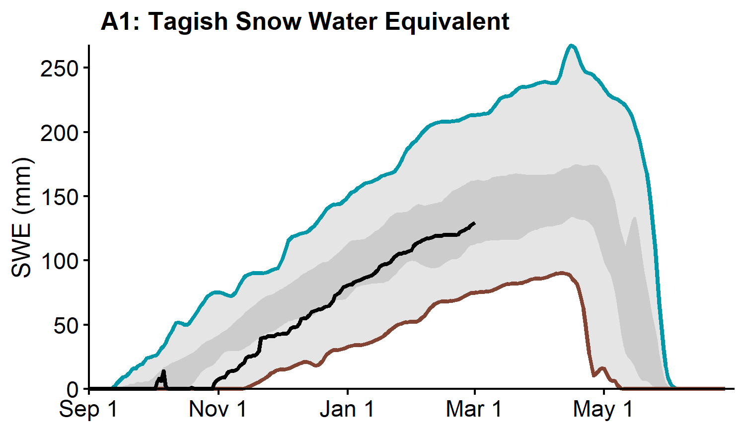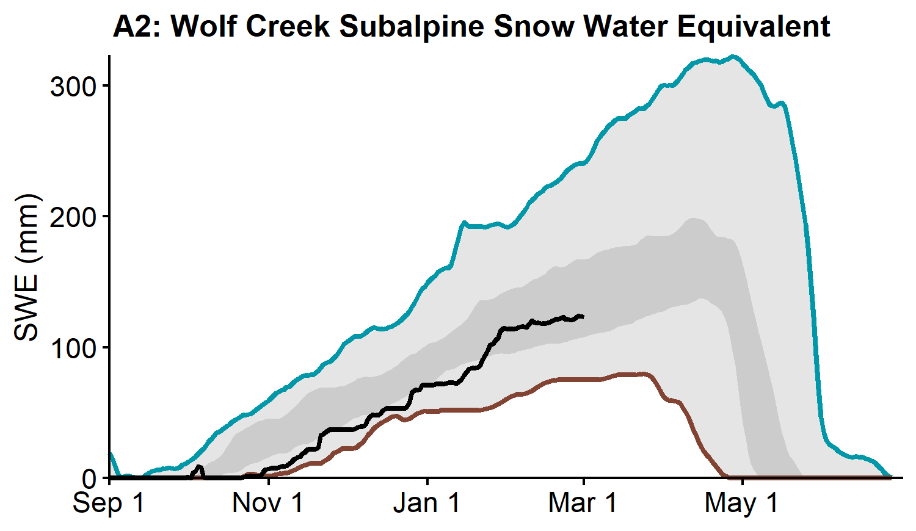
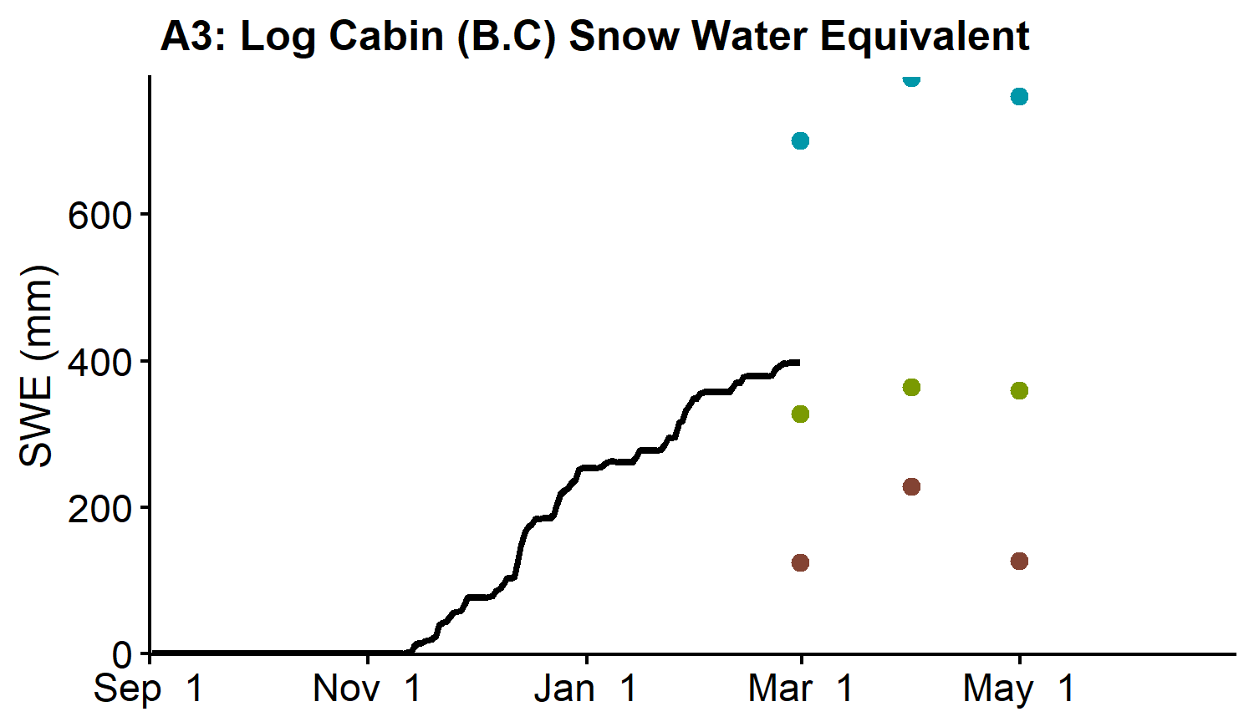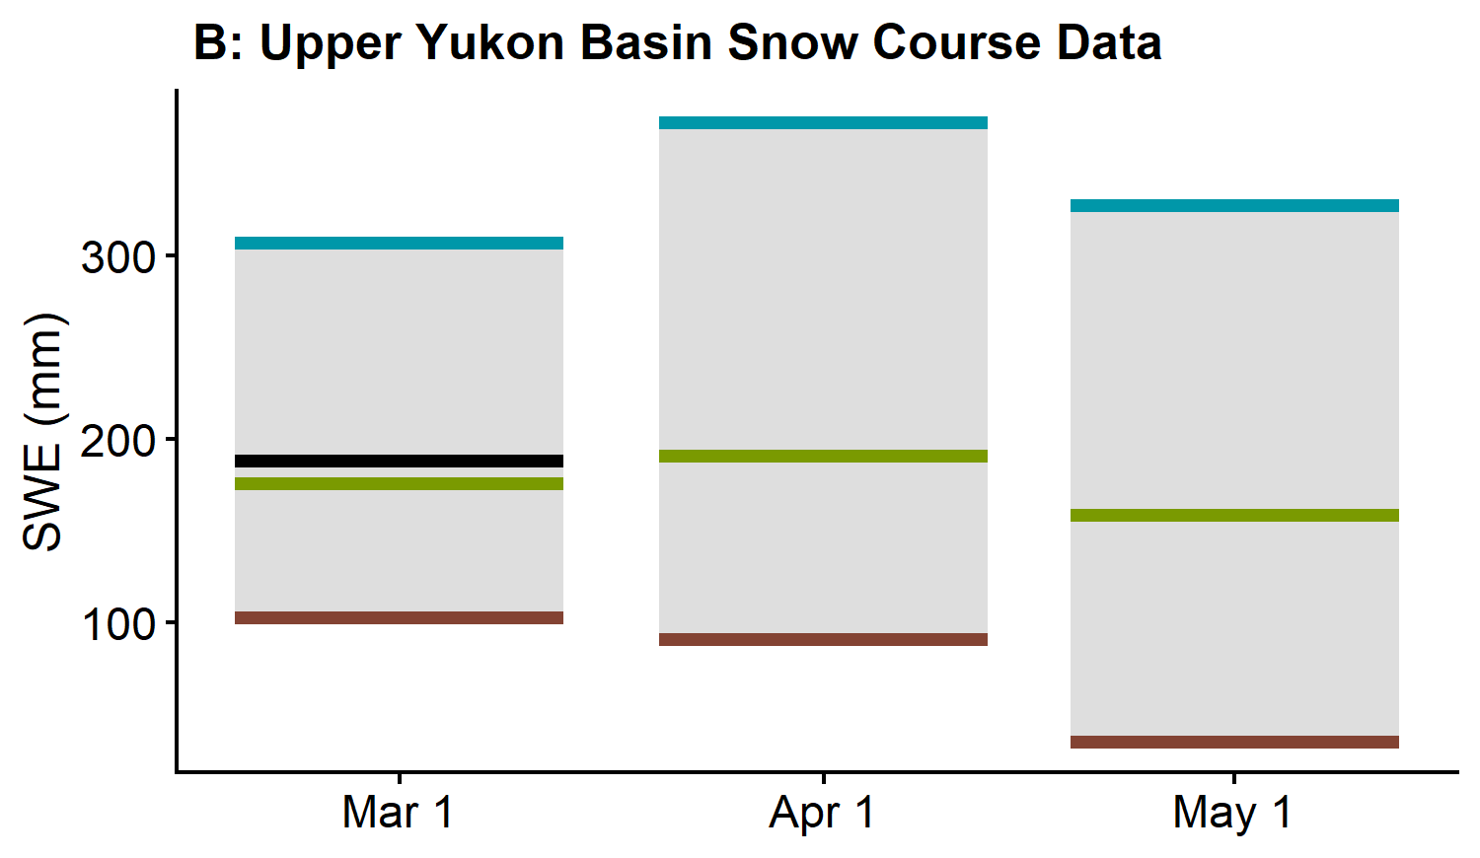
Whitehorse precipitation has been normal from October through February (Figure C). Cumulative winter precipitation was 99% of historical median on March 1. Cumulative degree-days of freezing (CDDF) are 82% of historical median, with 1285°C-Days on March 1 (Figure D), which suggests thinner than normal ice thickness on rivers and lakes of the region.
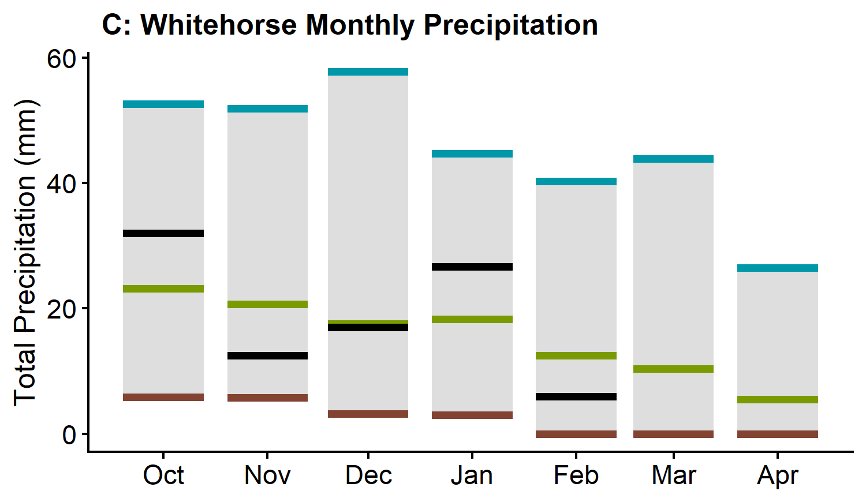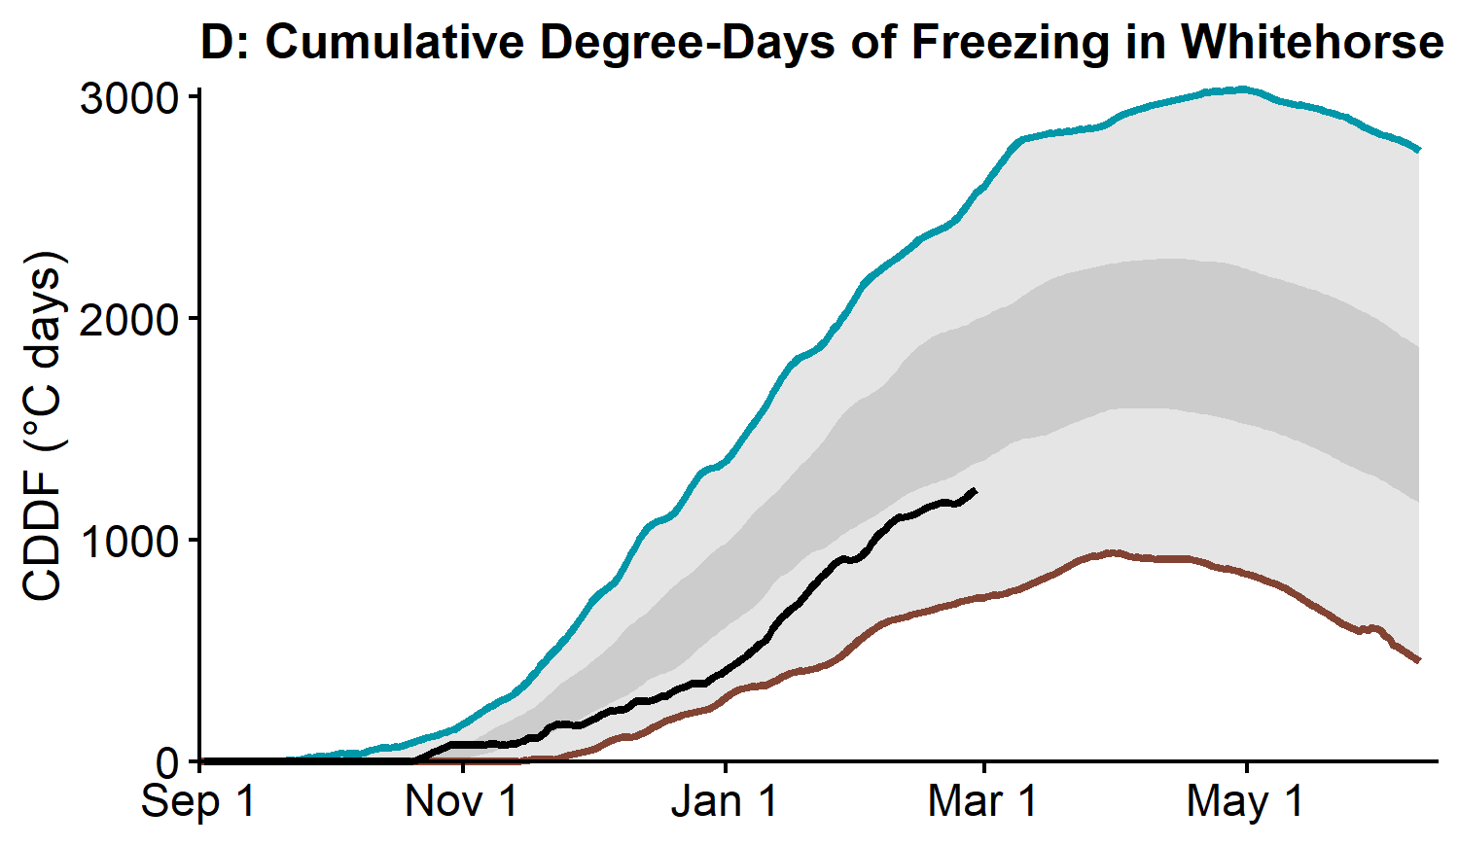
The measured water surface elevation (relative to sea level) in Marsh Lake is currently above average (Figure E1). The current snow and groundwater conditions suggest that water levels will be —— average this summer. However, weather conditions over the spring and summer will determine the peak water level in Marsh Lake, which typically occurs in late summer in response to peak glacial runoff and large precipitation events. Lake Laberge level is currently average (Figure E2). Lake Laberge follows a similar summer pattern to the upper Southern Lakes and is expected to experience —— average water levels this summer.
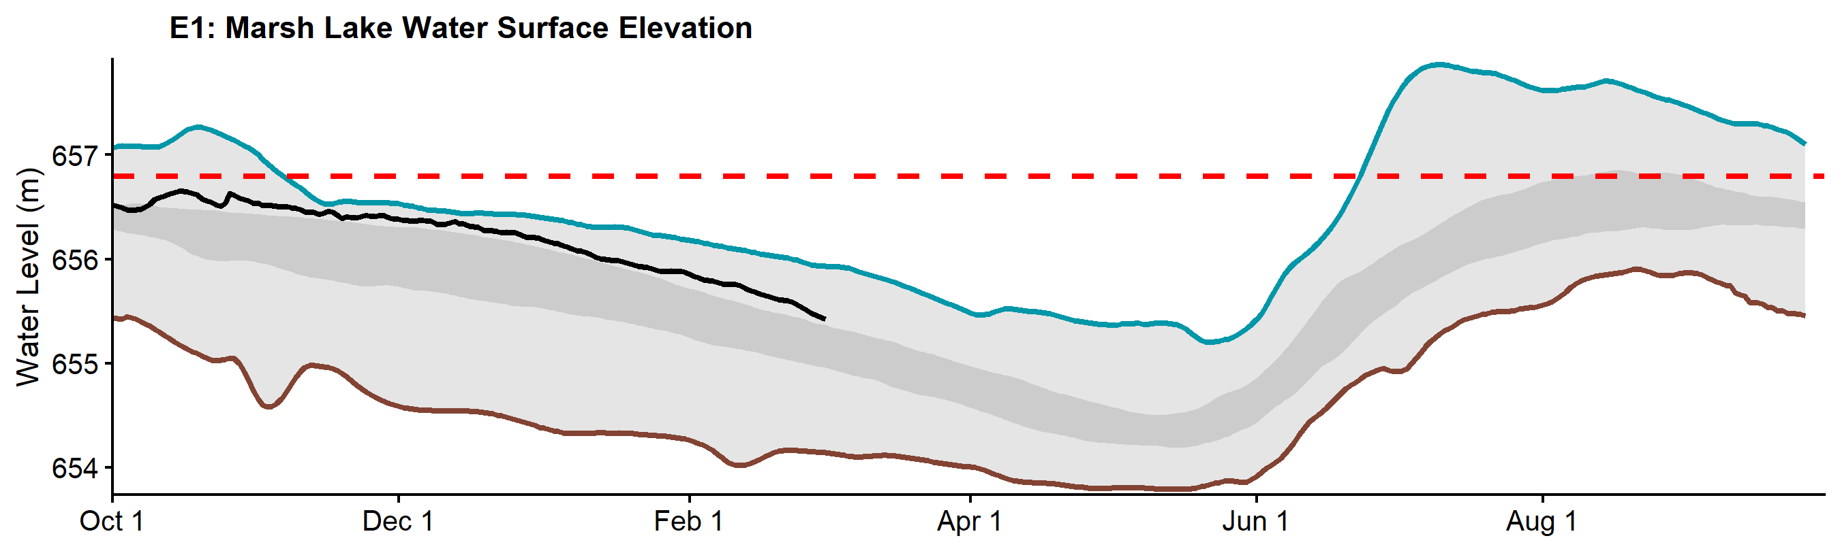
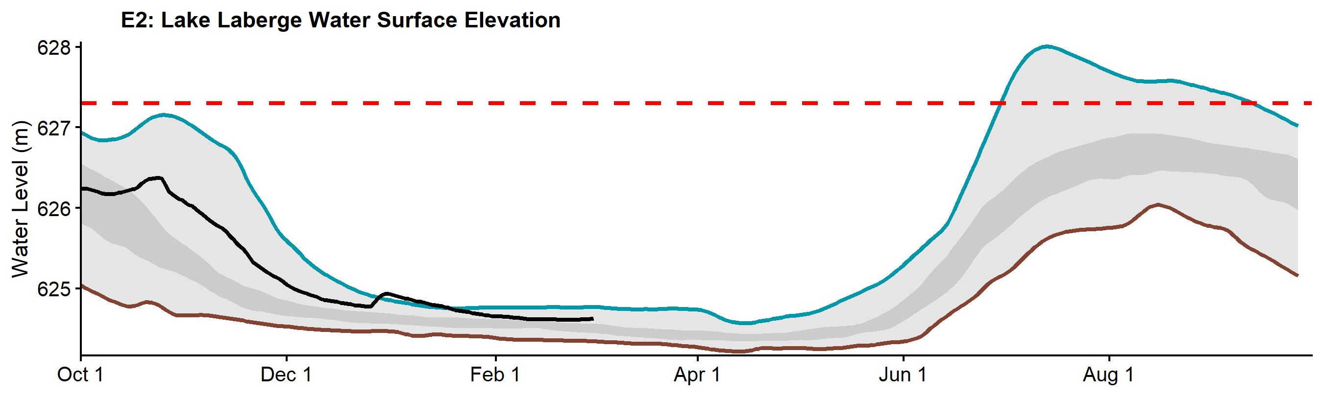

Teslin River Basin
The Teslin River Basin snowpack is close to average. The basin-averaged Snow Water Equivalent (SWE) is estimated at 97% of the historical median, with 159 mm as of March (Figure B).
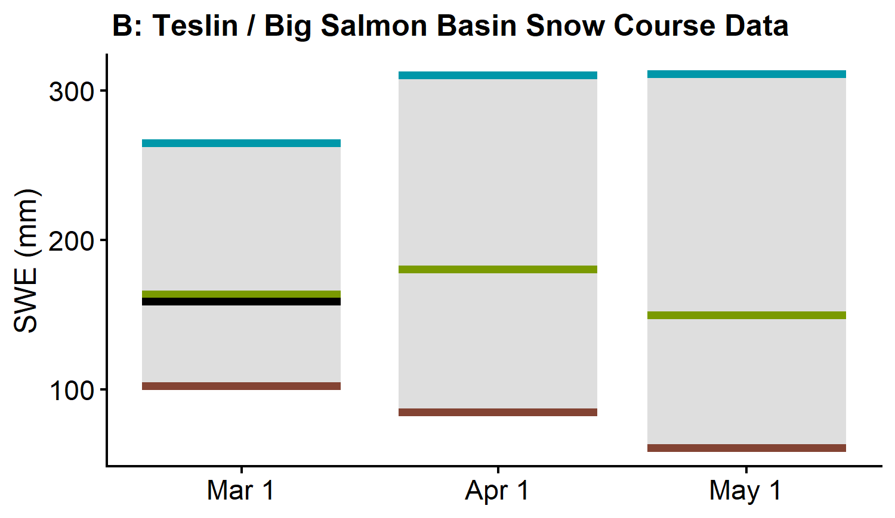
Teslin precipitation has been above normal from October through February (Figure C). Cumulative winter precipitation was 132% of historical median on March 1. Cumulative degree-days of freezing (CDDF) are 84% of historical median, with 1394°C-Days on March 1 (Figure D), which suggests thinner than normal ice thicknesson rivers and lakes of the region.
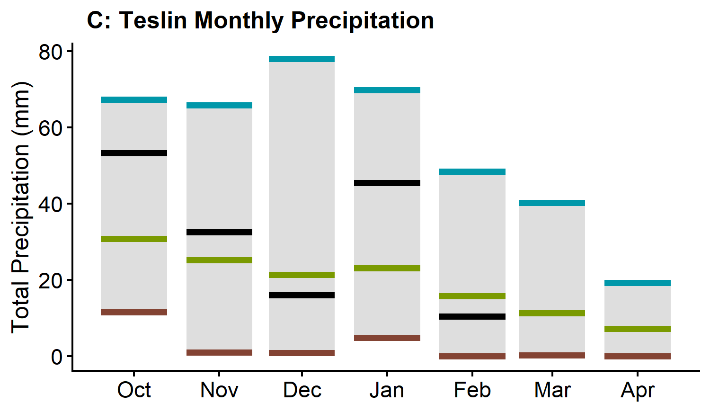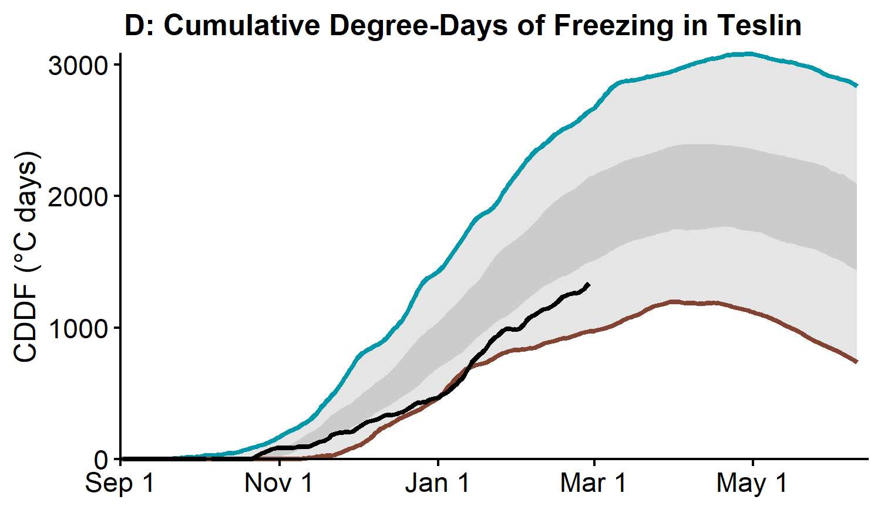
The measured water surface elevation (relative to sea level) in Teslin Lake is currently close to average (Figure C). Teslin Lake typically peaks in late June and is predominantly snowmelt driven. The —— snowpack and —— water level suggest that summer water levels will be —— . Peak water levels will depend on spring weather patterns.
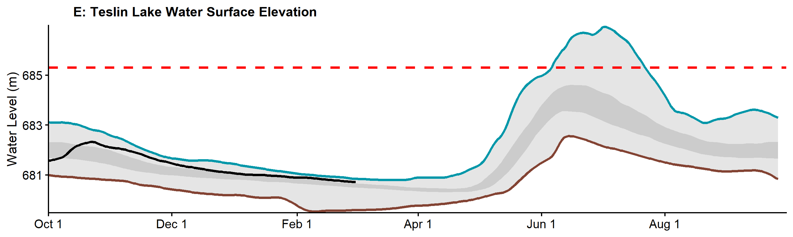

Central Yukon River Basin (Carmacks)
The Central Yukon River Basin snowpack is below average. The basin-averaged Snow Water Equivalent (SWE) is estimated to be 80% of the historical median, with 70 mm as of March 1 (Figure B).
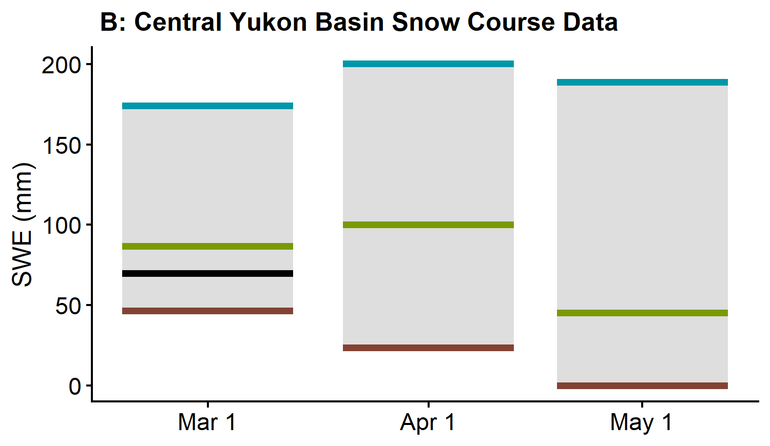
Carmacks precipitation has been close to normal from October through February (Figure C). Cumulative winter precipitation was 95% of historical median on March 1. Cumulative degree-days of freezing (CDDF) are 88% of historical median, with 2016°C-Days on March 1 (Figure D), which suggests thinner than normal ice thickness on rivers and lakes of the region.
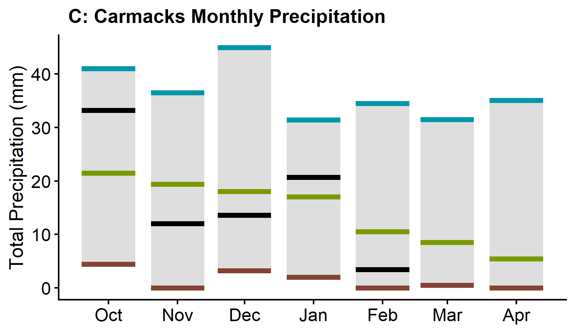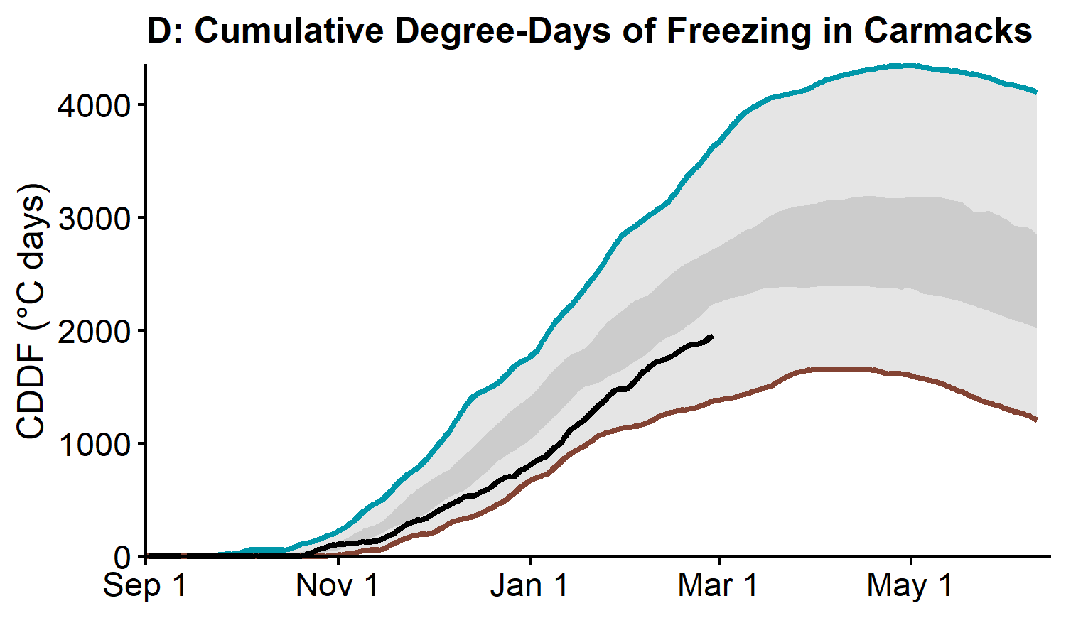
The estimated Nordenskiold River discharge is currently average (Figure E). The —— average snowpack combined with —— winter flows in the watershed suggests spring freshet flow volumes will be —— average. A combination of local conditions such as ice thickness, freeze-up levels, and current flow volumes suggest a —— average ice jam risk. Weather conditions in March and April will determine the most probable spring scenario.

Pelly River Basin
The Pelly River Basin snowpack is below average. At Twin Creeks Meteorological Station, Snow Water Equivalent (SWE) is estimated to be 93% of the historical median (Figure A). The Pelly River basin-averaged SWE is estimated to be 81% of the historical median, with 118 mm as of March 1 (Figure B).
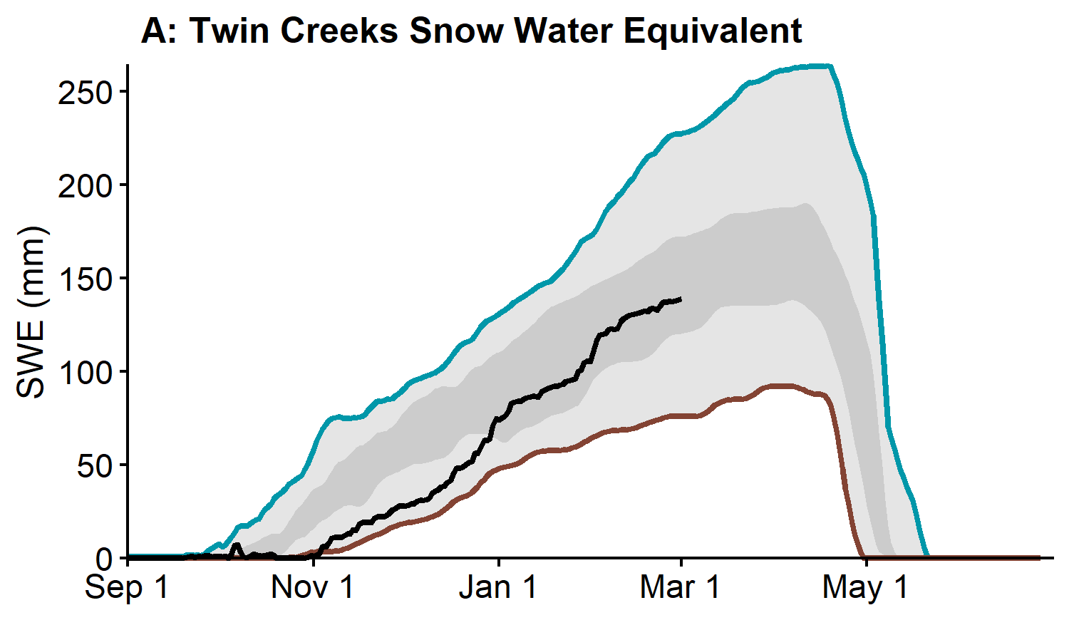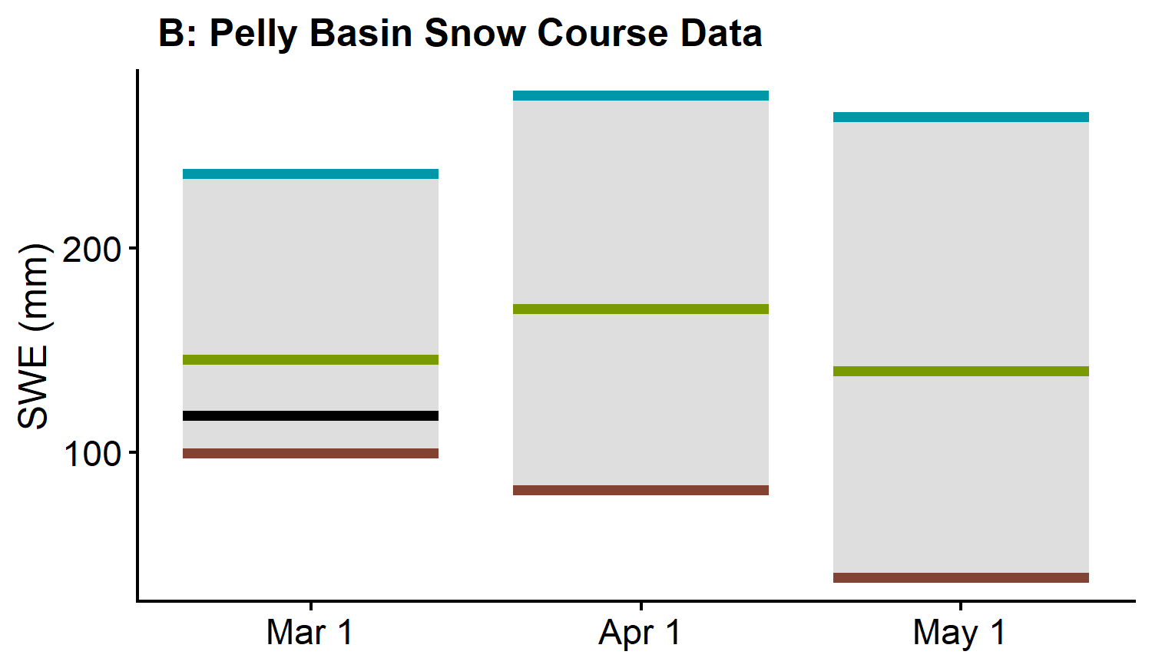
There are no precipitation data available at Faro but the snowpack data indicates that it has been below normal. Cumulative degree-days of freezing (CDDF) are 89% of historical median, with 1934°C-Days on March 1 (Figure C), which suggests thinner than normal ice thickness on rivers and lakes of the region.
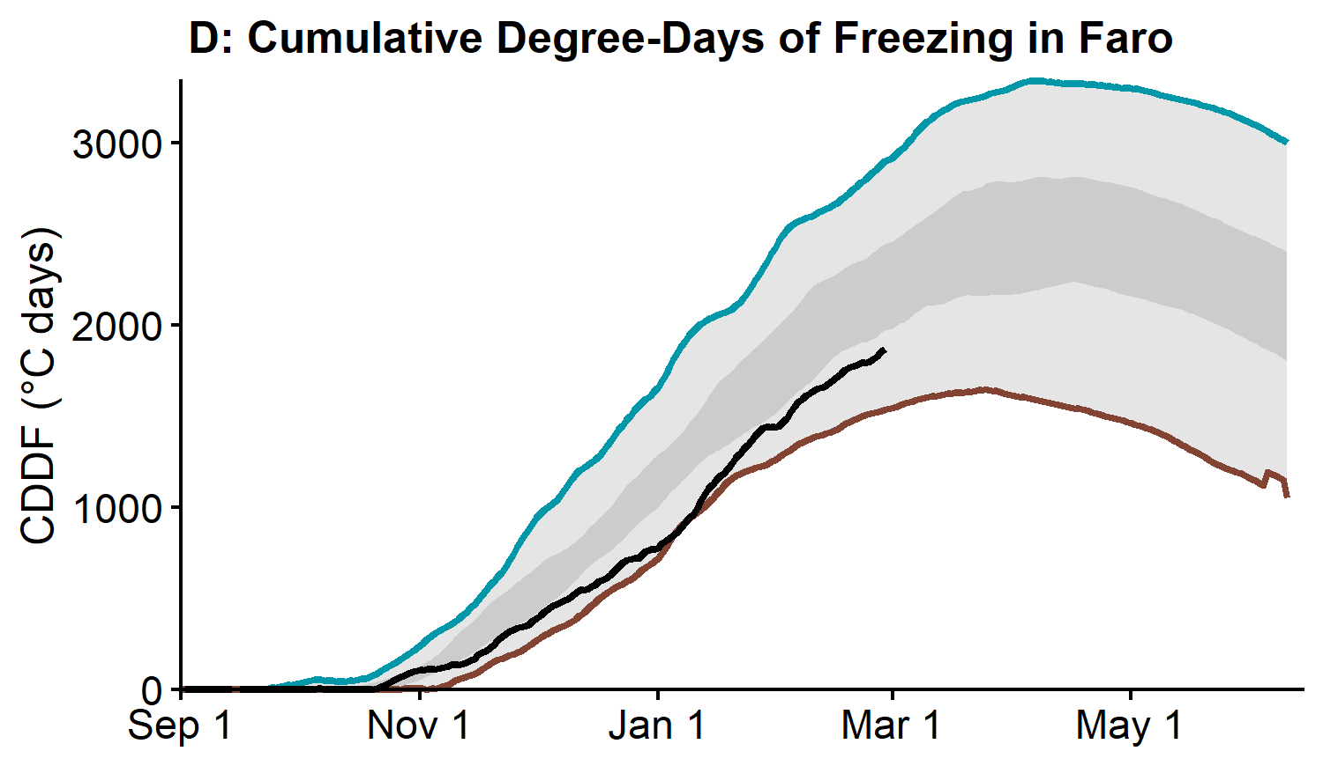
The estimated Pelly River discharge at Pelly Crossing is currently close to average (Figure E). The —— average snowpack combined with —— winter flows in the watershed suggests spring freshet flow volumes will be —— average with a potential for —— spring freshet flows. A combination of local conditions such as ice thickness, freeze-up levels, and current flow volumes suggest a —— average ice jam risk. Weather patterns leading to breakup and the spring freshet will play a critical role in determining potential ice jam severity and peak water levels.

Stewart River Basin
The Stewart River Basin snowpack is below average. At Withers Lake Meteorological Station, Snow Water Equivalent (SWE) is estimated to be 100% of the historical median (Figure A). The Stewart River basin-averaged SWE is estimated to be 78% of the historical median, with 122 mm as of March 1 (Figure B).
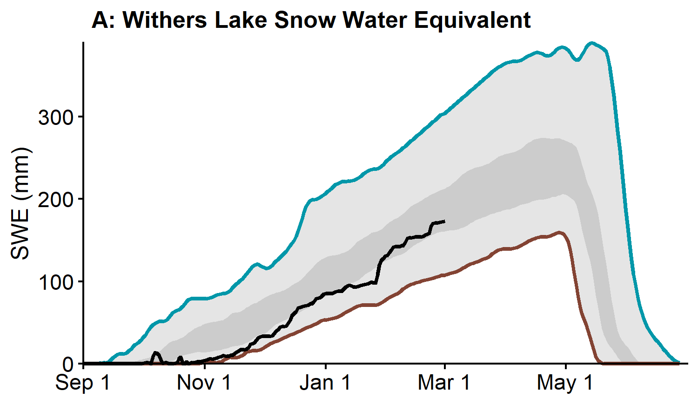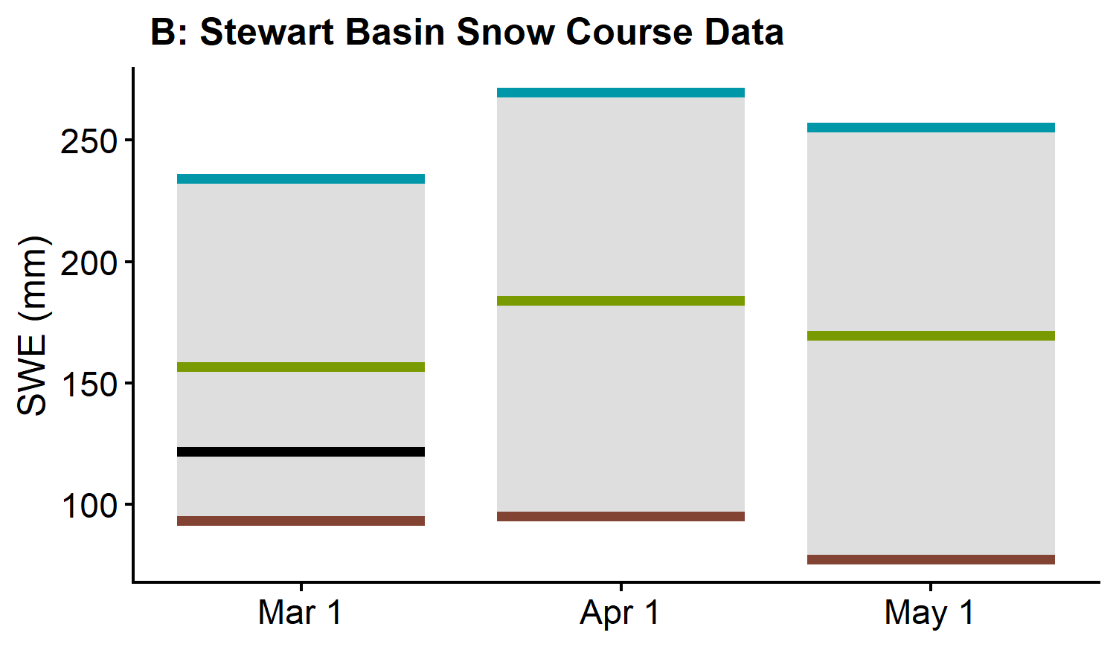
Mayo precipitation has been normal from October through February (Figure C). Cumulative winter precipitation was 98% of historical median on March 1. Cumulative degree-days of freezing (CDDF) are 91% of historical median, with 2242°C-Days on March 1 (Figure D), which suggests close to normal ice thickness on rivers and lakes of the region.
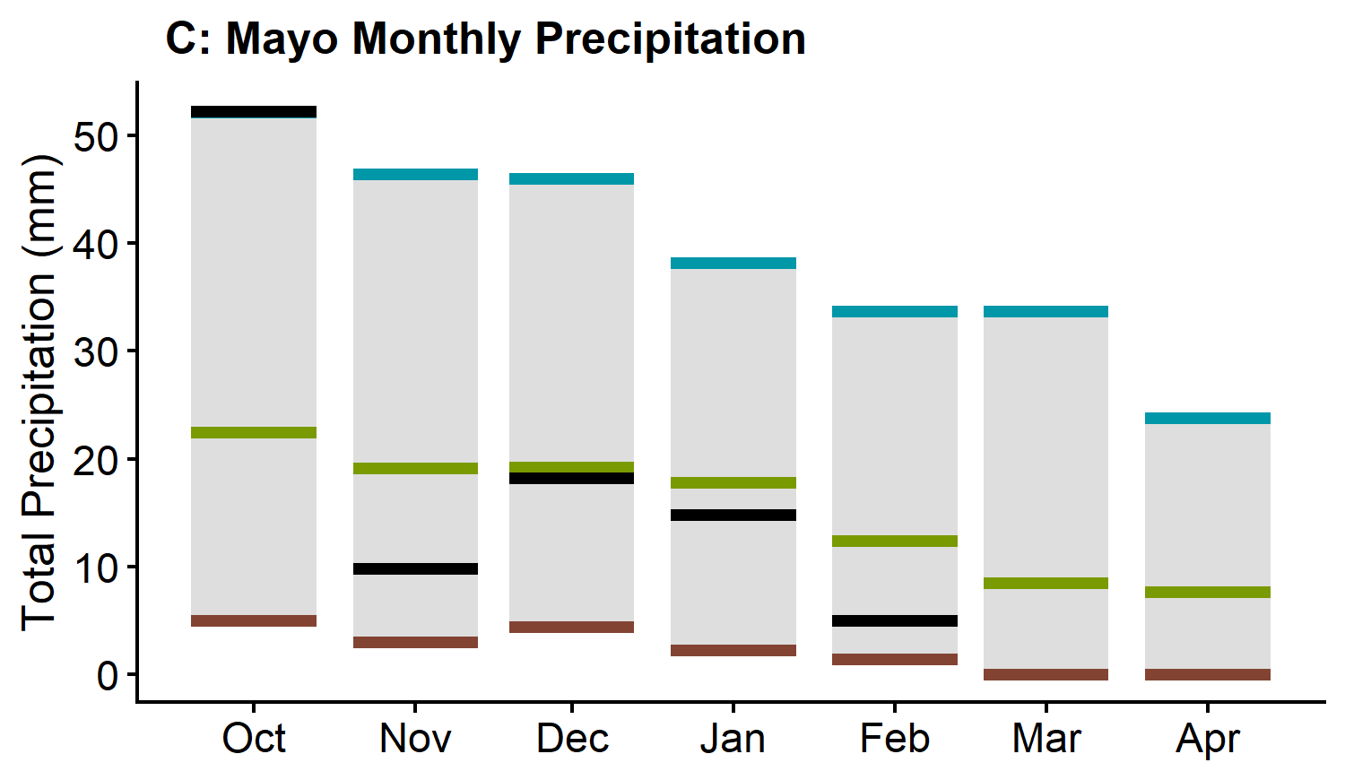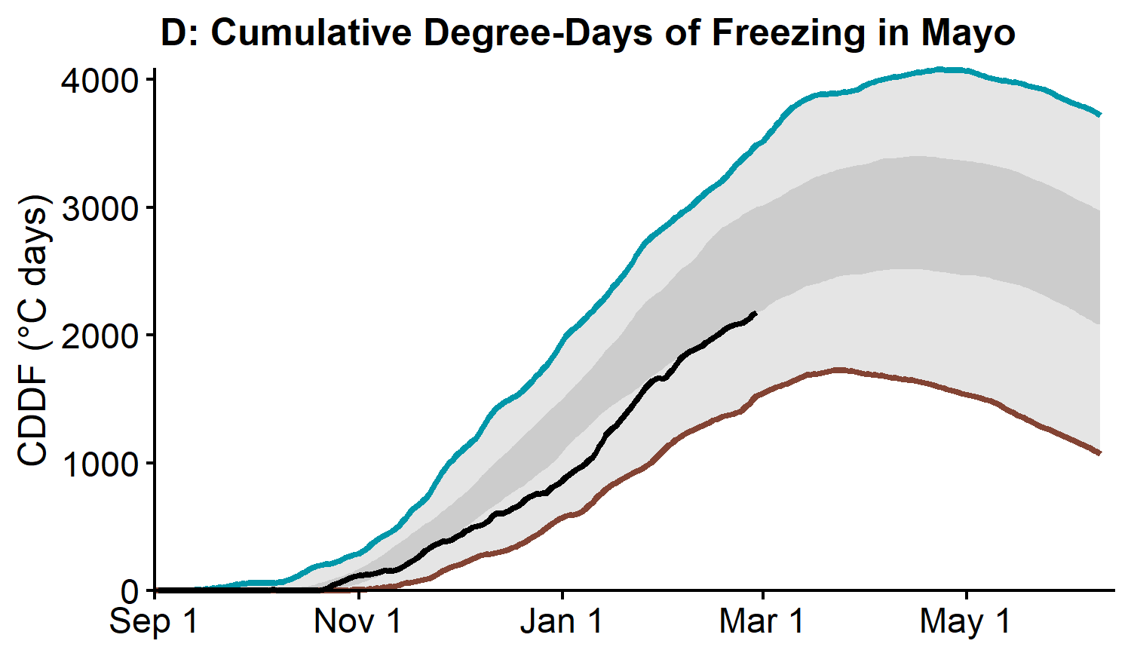
The estimated Stewart River discharge at the outlet is currently average (Figure E). The —— average snowpack combined with —— winter flows in the watershed suggests spring freshet flow volumes will be —— average. A combination of local conditions such as ice thickness, freeze-up levels, and current flow volumes suggest a —— average ice jam risk. Weather patterns leading to breakup and the spring freshet will play a critical role in determining potential ice jam severity and peak water levels.

White River Basin
The White River Basin snowpack is average. The basin-averaged Snow Water Equivalent (SWE) is estimated to be 101% of the historical median, with 85 mm as of March 1 (Figure B).
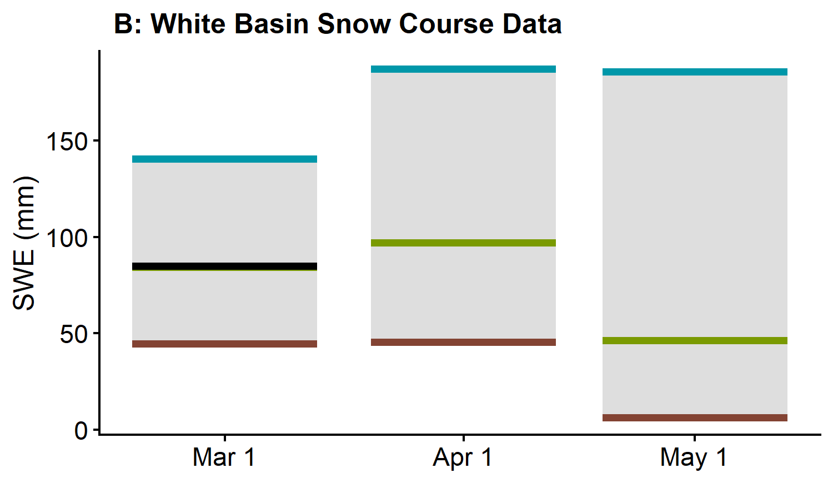
The estimated White River discharge at the Alaska Highway is currently above average (Figure E). In this watershed, high flows are dominated by mountain snowmelt and glacial melt that are largely influenced by summer temperatures and precipitation. The —— average snowpack combined with —— average winter flows suggests spring freshet flow volumes will be —— average with a potential for —— spring freshet water levels. Warm and/or wet weather anomalies during the next four months will —— generate high peak flows, including in rivers and streams crossing the Alaska Highway in the Kluane region.

Lower Yukon River Basin (Dawson region)
The Lower Yukon River Basin snowpack is above average. Established in 2022, King Solomon Dome Meteorological Station registered Snow Water Equivalent (SWE) at 112% of the historical median when compared with the manual snow survey record for that site (Figure A). The Lower Yukon basin-averaged SWE is estimated to be 124% of the historical median, with 173 mm as of March 1 (Figure B).
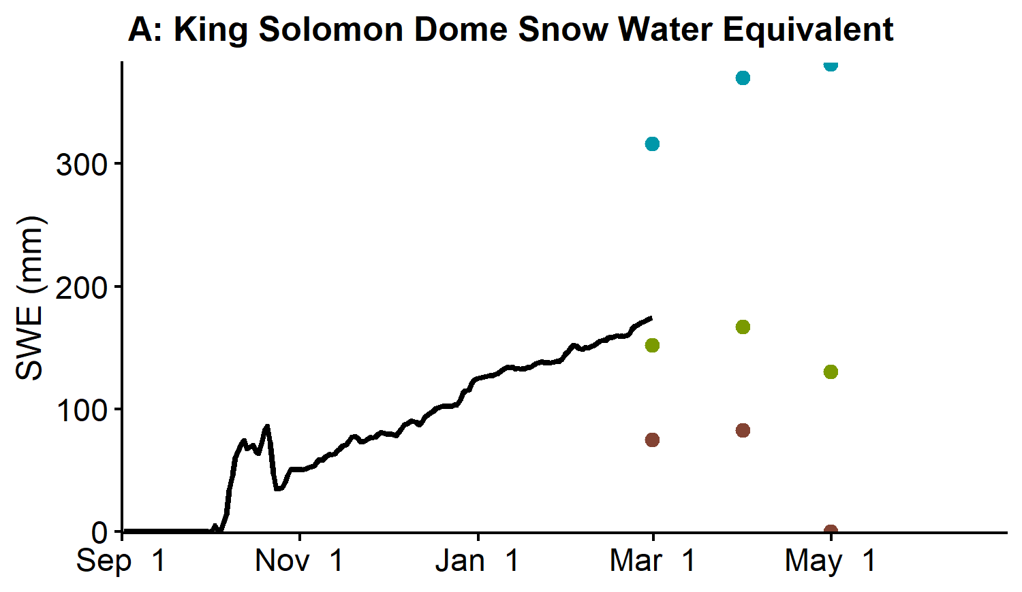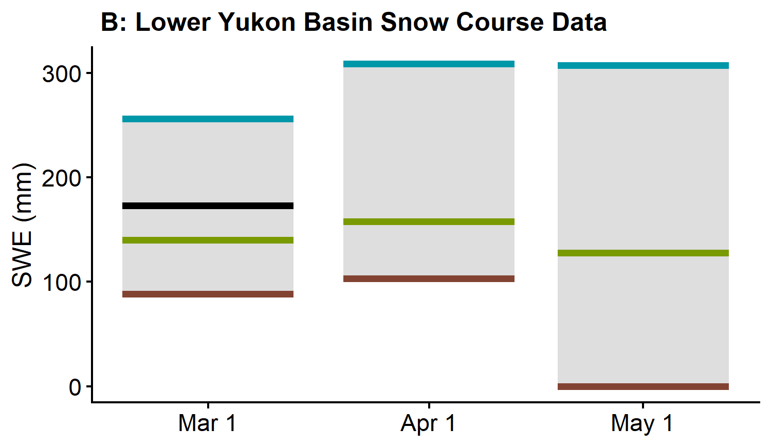
Precipitation at Dawson Airport has been well above normal from October through February (Figure D). Cumulative winter precipitation was 140% of historical median on March 1. Cumulative degree-days of freezing (CDDF) are 93% of historical median, with 2637°C-Days on March 1 (Figure D), which suggests close to normal ice thickness on rivers and lakes of the region.
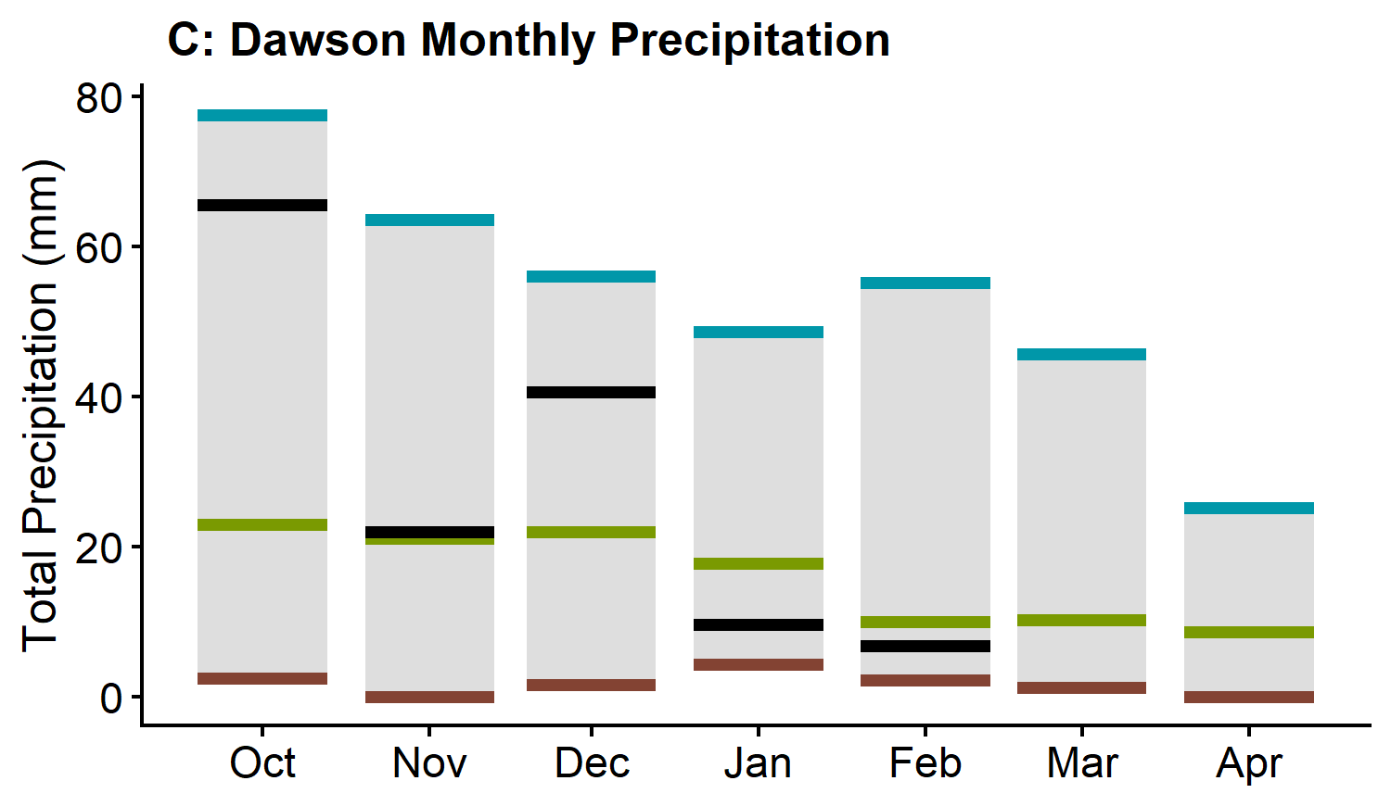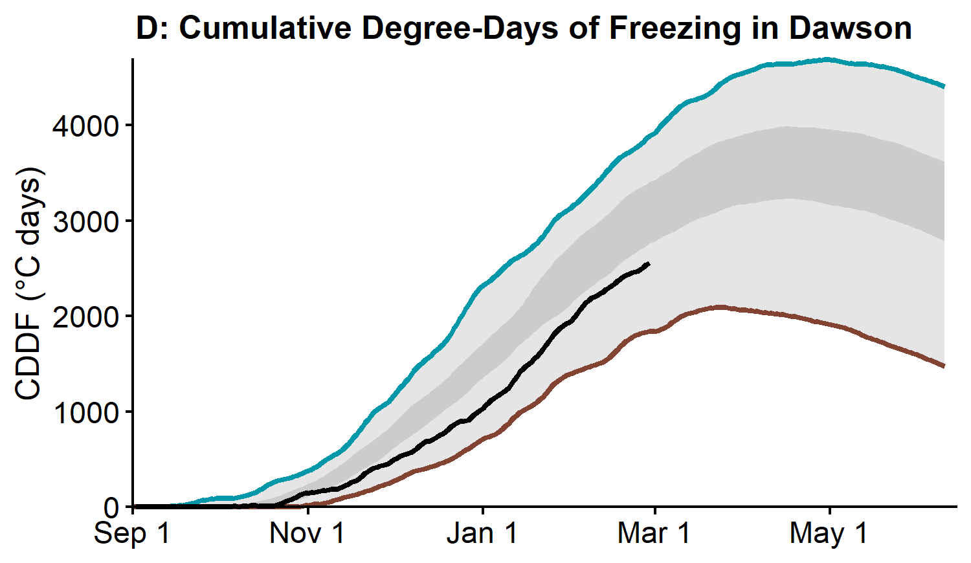
The estimated Yukon River discharge above White River is currently above average (Figure E1) while the estimated Klondike River discharge above Bonanza Creek is currently average (Figure E2). The —— average snowpack combined with —— average winter flows suggests spring freshet flow volumes will be —— average with a —— potential for —— spring freshet water levels. Weather conditions in —— will determine the most probable spring scenario. A combination of local conditions such as ice thickness, freeze-up levels, and current flow volumes suggest an —— ice jam risk. Weather patterns leading to breakup and the spring freshet will play a critical role in determining potential ice jam severity and peak water levels. These statements also apply to the Klondike River.

Porcupine River Basin
The Porcupine River Basin snowpack is well above average. The basin-averaged Snow Water Equivalent (SWE) is estimated to be 174% of the historical median, with 200 mm as of March 1 (Figure B).
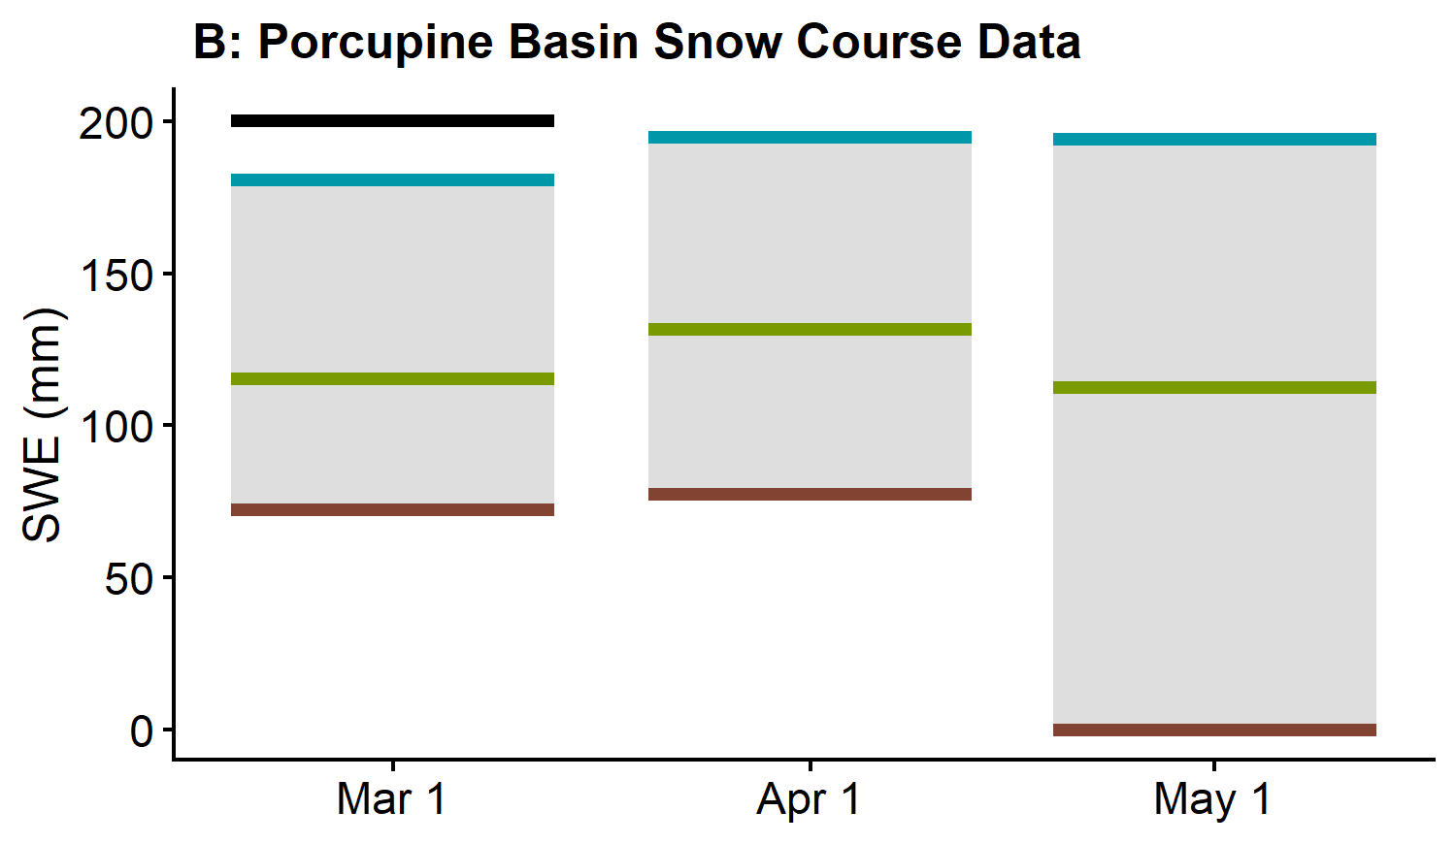
Precipitation at Old Crow Airport has been well above normal from October through February (Figure C). Cumulative winter precipitation was 137% of historical median on March 1. Cumulative degree-days of freezing (CDDF) are 94% of historical median, with 3186°C-Days on March 1 (Figure D), which suggests close to normal ice thickness on rivers and lakes of the region.
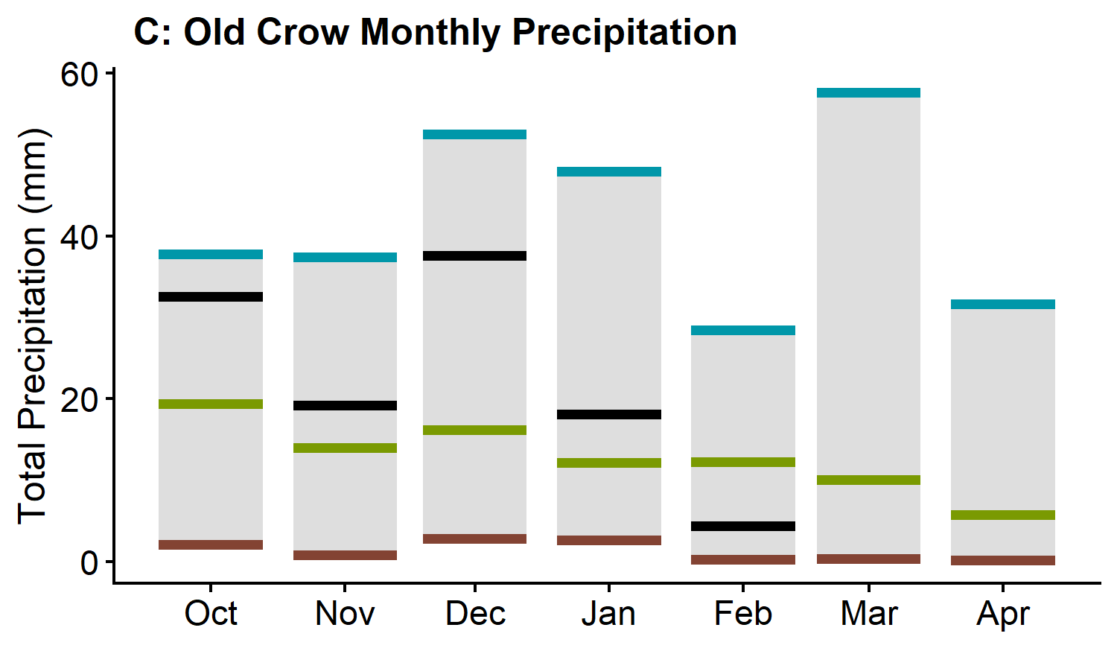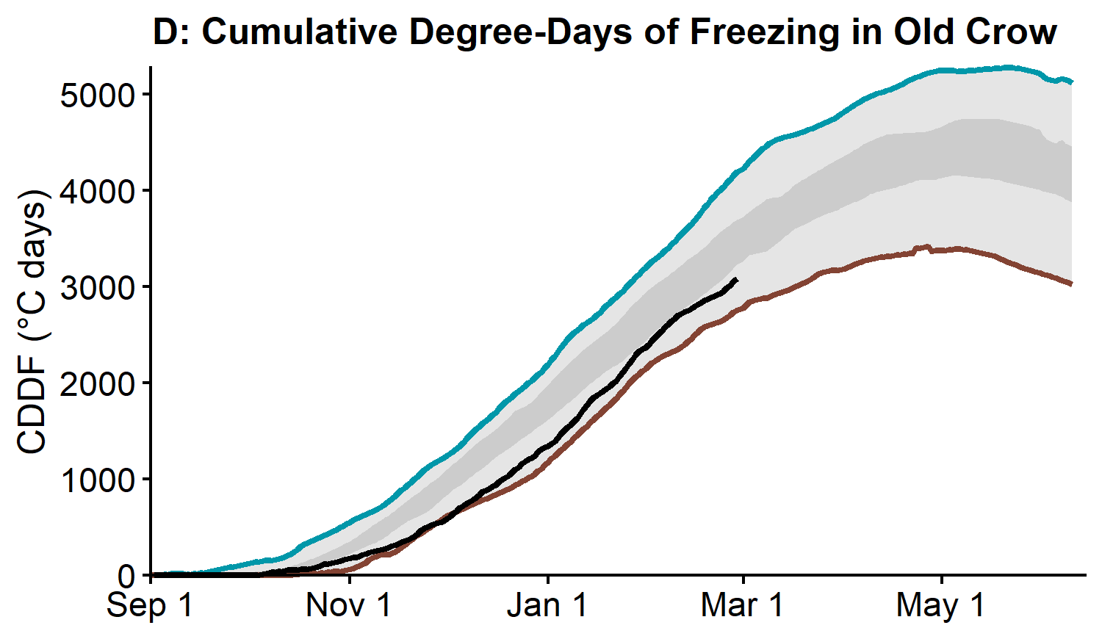
The estimated Porcupine River discharge is currently above average (Figure E). The —— average snowpack combined with —— winter flows suggests that spring freshet flow volumes will be —— average. Weather patterns leading to breakup and the spring freshet will play a critical role in determining potential ice jam severity and peak water levels

Peel River Basin
The Peel River Basin snowpack is well above average. The basin-averaged Snow Water Equivalent (SWE) is estimated to be 138% of the historical median, with 166 mm as of March 1 (Figure B).
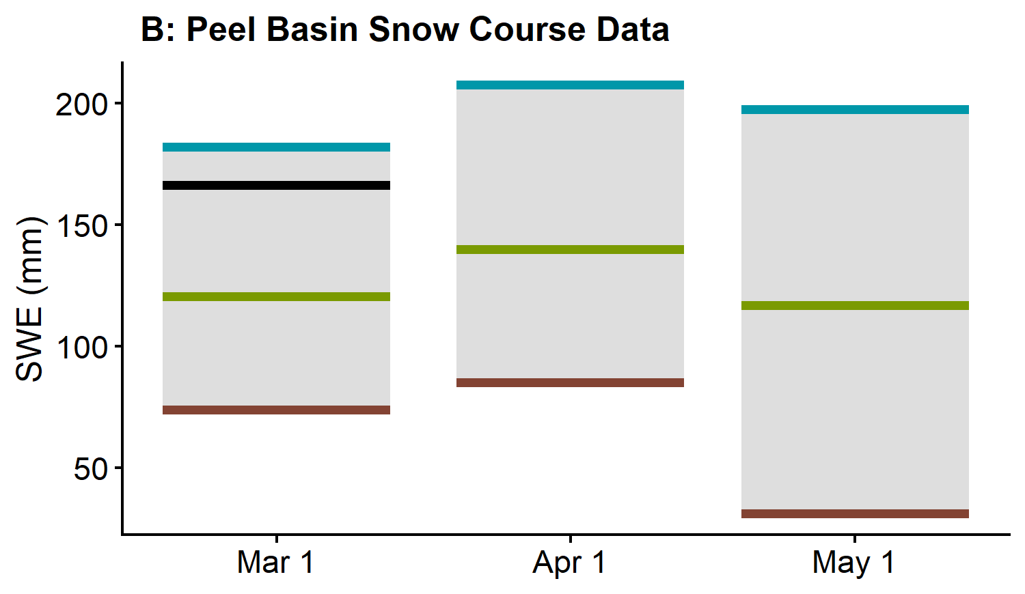
The estimated Peel River discharge is below average (Figure E). The —— average snowpack combined with —— winter flows suggests spring freshet flow volumes will be —— average. Weather conditions in March and April will determine the most probable spring scenario.

Liard River Basin
The Liard River Basin snowpack is average. At Hyland Meteorological Station, Snow Water Equivalent (SWE) is estimated to be 105% of the historical median (Figure A). The Liard River basin-averaged SWE is estimated to be 99% of the historical median, with 155 mm as of March 1 (Figure B).
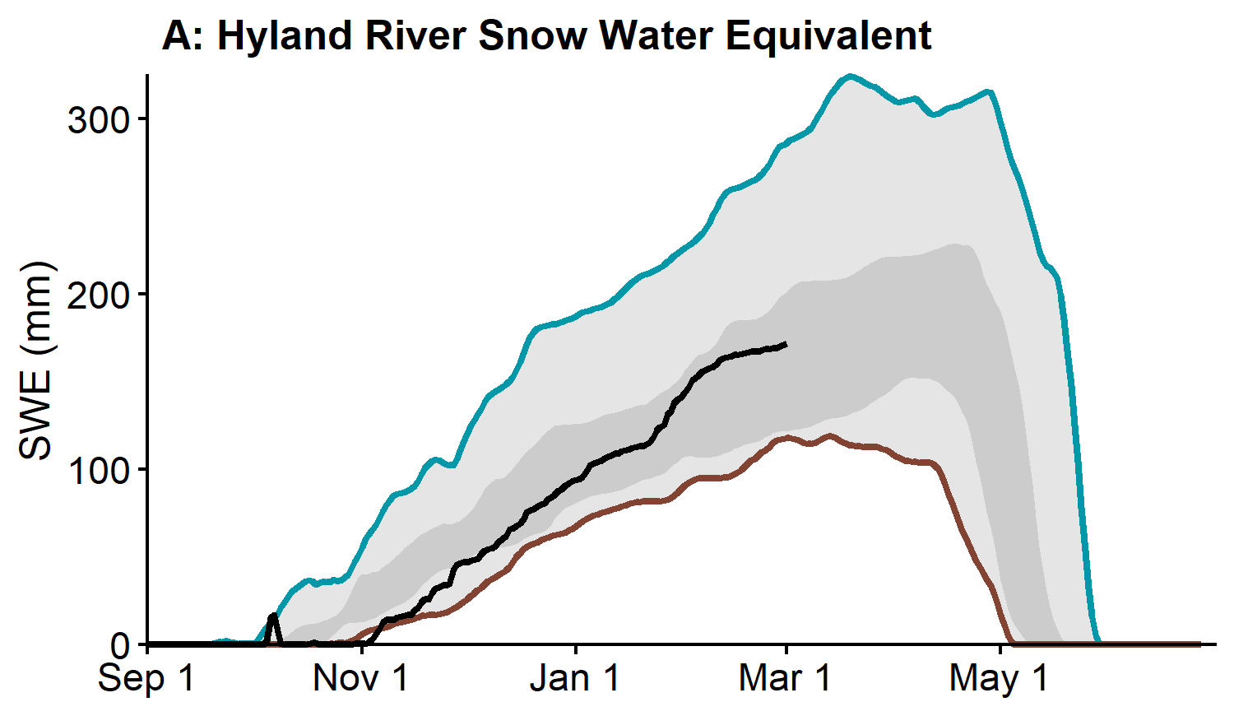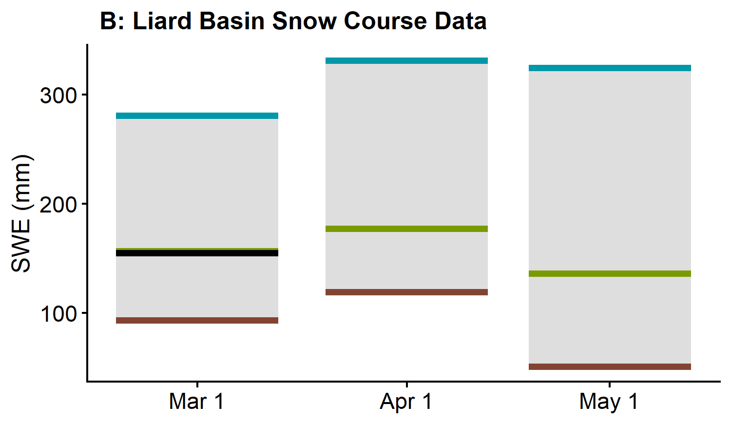
Precipitation at Watson Lake Airport has been normal from October through February (Figure C). Cumulative winter precipitation was 101% of historical median on March 1. Cumulative degree-days of freezing (CDDF) are 89% of historical median, with 2069°C-Days on March 1 (Figure D), which suggests thinner than normal ice thickness on rivers and lakes of the region.
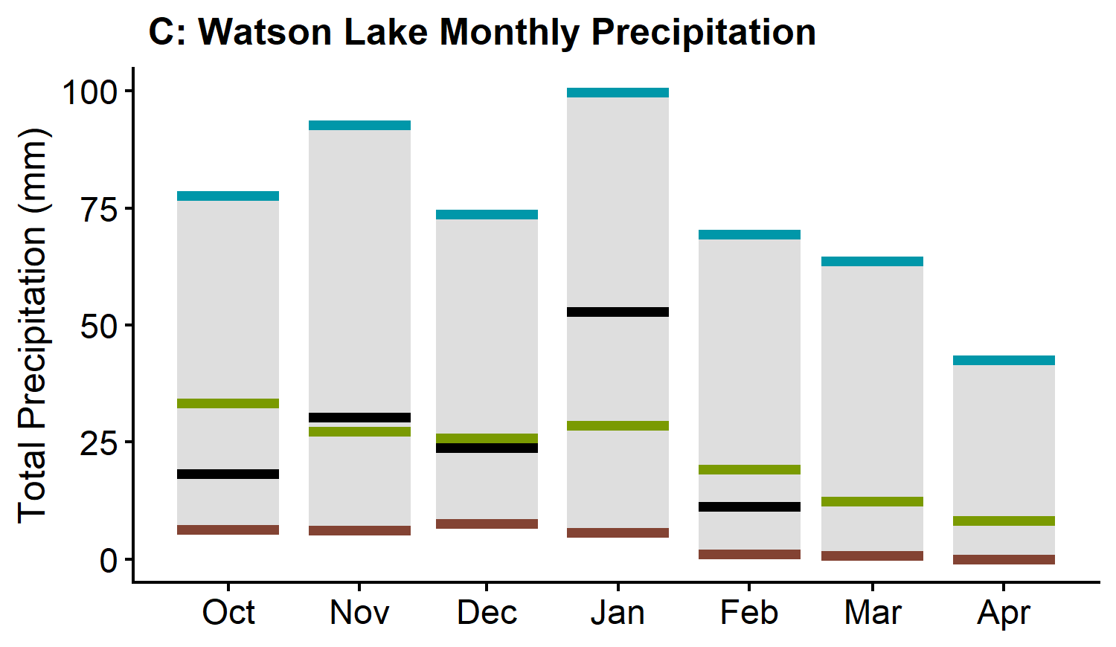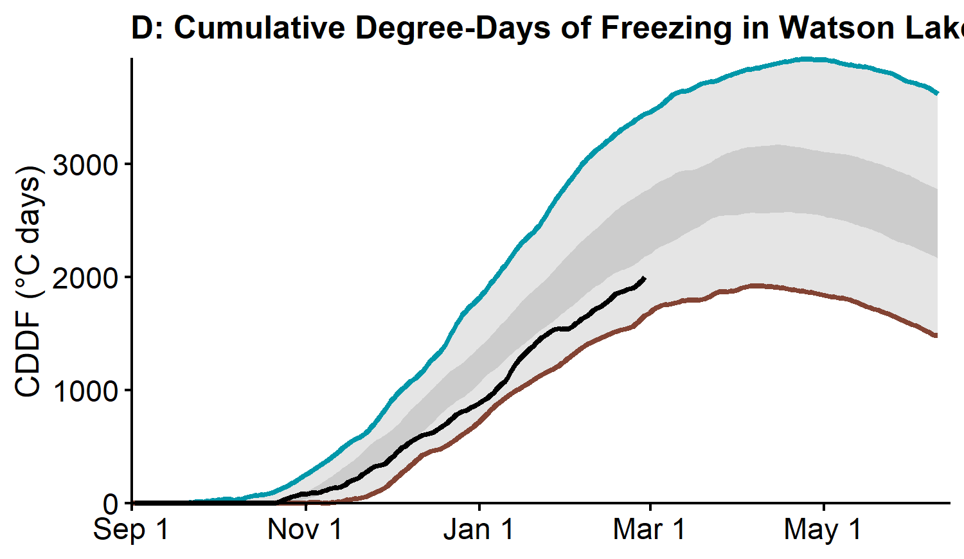
The estimated Liard River discharge at Upper Liard is currently close to average (Figure E). The —— average snowpack in the watershed combined with —— average winter flows suggests spring freshet flows and levels will be —— average. Weather patterns leading to spring freshet have the potential to generate —— average water levels on small to medium creeks and rivers including those crossing the Alaska and Robert Campbell highways.

Alsek River Basin
The Alsek River Basin snowpack is close to average. The basin-averaged Snow Water Equivalent (SWE) is estimated to be 90% of the historical median, with 112 mm as of March 1 (Figure B).
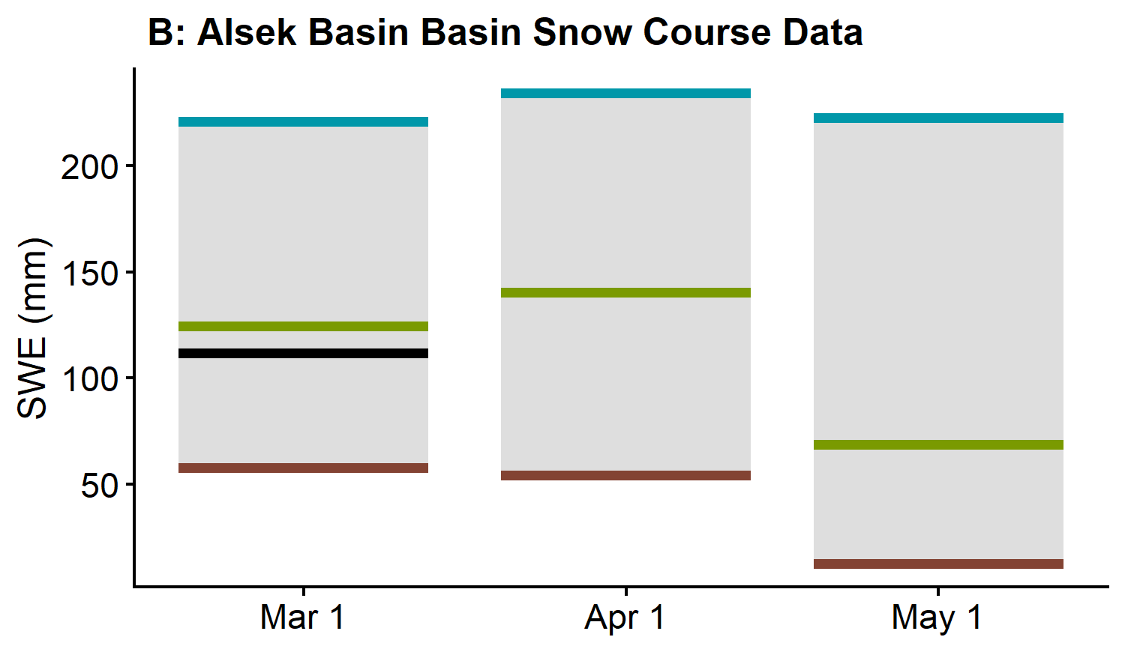
The estimated Alsek River discharge is currently above average (Figure E). High flows in this watershed are dominated by mountain snowmelt and glacial melt that are largely influenced by summer temperatures and precipitation. The snowpack in the St. Elias Range is likely to generate —— average freshet volumes. Weather conditions over the spring and summer will determine peak flows.

Drainage Basin and Snow Course
Table generation error: missing values are not allowed in subscripted assignments of data frames

Date notes:
N.S. - No survey

SWE notes:
E - Estimate
B - Survey date is outside of valid sampling range
R - New record

Median historical SWE and Years of record notes:
C - Composite historical record. Current location measurements combined with historical record from discontinued nearby location, adjusted based on overlapping years of record.
- Whitehorse Airport B (Ice Lake) combines records from the old Whitehorse Airport snow course located within the airport grounds with new measurements taken a few hundred meters to the West of the airport. Two years of overlapping records exist (2023‑2024). The new snow course uses historical SWE records from the old location (1965‑2022) without any adjustments.
- Twin Creeks B ccombines records from Twin Creeks A snow course located at the West end of the Twin Creeks air strip with new measurements taken at the East end of the air strip. Six years of overlapping records (2016 and 2021‑2025) are currently used to adjust the historical SWE copied from Twin A into Twin B (a correction factor of 0.83 applies to 1977‑2015 SWE data).
- Twin Creeks A sampling continues and records displayed in the Twin A row in the above table are not subject to any adjustments. Twin A historical period (1977‑2024) is missing four year of record (2017‑2020).
- Hyland River B combines records from the old Hyland River snow course located near the Hyland River air strip with new measurements taken 6 kilometers to the north of the old station. Five years of overlapping records (2018‑2022) were used to adjust the historical SWE copied from the old location into the new one (a correction factor of 1.09 applies to the 1976‑2017).

Map 4. Location of Water Resources Snow Courses

